04.02 Event Programming

Event programming

Recently the idea of keyboard interaction was introduced as a way for programs to respond to the end user. Keyboard interaction is an example of event programming – a method of writing programs to respond to events like pressing a key.

With GUI programs’ visual widgets, there are many more kinds of events that can be detected by Python. The programmer must write code for the events they are interested in using.
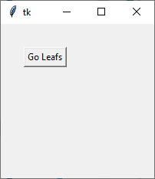
For example, a common widget-event combination is a Button click – clicking the mouse button is an event. A button is a widget that normally looks like a raised rectangle. The user positions the cursor over the button, then presses on the left-mouse button to “click” the widget button. (Tabbing to the button, then pressing the Enter key is the same as clicking on the button)

Button widget

Try – start a basic GUI program, with a label at location (0, 0).
(By default, add a title to the window and fix it to 350x200)

Here’s template code:

import tkinter

#Define events, which are functions

#Main window and widgets
def main():
window = tkinter.Tk()
window.title (“Event programming”)
window.geometry(“350x200”)

first_label = tkinter.Label(window, text=””)
first_label.place (x = 10, y = 10)

window.mainloop ()

#####################
main()

Add the following statement to create a button but add a new parameter:

hello_button = tkinter.Button (window, text=”Click me”,
command=hello_button_clicked)

The new parameter “command” is assigned the name of an event handler that contains the code to be run when the event happens to the widget (in this case, clicking on the button on the GUI). Notice there are no brackets (ie () ) after the event handler name.

There is nothing special about naming the handler “hello_button_clicked” – it could be named “fred” and the code would still work. Follow the usual conventions for naming an identifier like a function.

Second, write the event handler code (hint: it’s written like a function, but not called like a function):

def hello_button_clicked ():
first_label.configure (text=”Hello World”)

The keyword def means the code is defining a new function. Notice the parentheses and colon at the end of this definition statement. Next follows an indented block of code which will execute when the event occurs. The new widget command (or “method”) *.configure() allows the code to change a characteristic of a widget. In this case, the label’s text will change from blank to “Hello World”. *.configure() can be use to update any characteristic of a widget (note: this needs to be fully confirmed).

These event handlers must be written/defined /appear in the *.py file before they are referenced. They must be written before the widget is created. If not, the program will run into a “Undefined function” run-time error message. This is similar to trying to use a variable before it exists/has been assigned a value.

The entire program should now look like the following (the big hash tag line is just added to visually show you the separate sections – the section where events handlers are written, and the main program which runs).

import tkinter

#Define events before programming the window
def hello_button_clicked ():
#This defines what the program will do whenever the button is
#clicked
first_label.configure (text=”Hello World”)

##########################################################

#Main window and widgets
window = tkinter.Tk()
window.title (“Event programming”)
window.geometry(“350x200”)

first_label = tkinter.Label(window, text=””)
first_label.place (x = 10, y = 10)

hello_button = tkinter.Button (window, text=”Click me”,
command=hello_button_clicked) #Notice no brackets
hello_button. place (x = 5, y = 30) #for parameters

window.mainloop ()

Now, when the program executes, it creates the GUI, then waits for events to occur. When an event occurs, the code in the event handler and only that code is executed.
(For advanced programmers: The purpose of the “mainloop” function at the end of the code becomes evident – it creates a loop within which the program waits for events to happen. When events happen, the appropriate event handler is executed).

Scope of variables

The scope of a variable refers to the section of the code that a variable is defined and can be used. This type of sectioning is not the same as sectioning the program into event handlers versus main program.

Strictly speaking, a variable defined in the main window section is only defined and usable in the main section. Any variable defined within an event handler only exists within that event handler, even if it has the same name as a variable in the main section of the program.

Example 1: def event_handler():
first_variable = 2 #fails

first_variable = 0 #statement in main body

Example 2: def event_handler():
global first_variable #event handlers will be the
first_variable = 2 #only place where global
#variables can be updated
#within functions
first_variable = 0 #statement in main body

In example 1, there will be run time error because within the scope of the event handler, “first_variable” has not been defined yet. Within that block of code, the program cannot see the “first_variable” variable which was assigned 2.

In example 2, the word “global” tells the event handler code to look outside the handler for the variable.

Try writing and running the example below. Use the template 04.02_example_template.py as a starting point.

import tkinter

def count_click ():
global click_count #click_count needs global here…
click_count = click_count + 1
counter_label.configure(text=click_count)

def main():
global click_count #...and here
global counter_label #but counter_label only needs it here

click_count = 0

window = tkinter.Tk()
window.title ("Counter")
window.geometry("350x200")

prompt_label = tkinter.Label(window, text="Number of clicks:")
prompt_label.place (x = 50, y = 10)

counter_label = tkinter.Label(window, text=" ")
counter_label. place (x = 50, y = 80)

counter_button = tkinter.Button(window, text = "Press Me",
command=count_click)
counter_button. place (x = 50, y = 40)

window.mainloop ()

############m
main()

Note: the variable click_count needs global both in the calling function and the called function because it is a simple data type variable and works under by pass by value. counter_label only needed one global statement since it is a complex data type variable, and works under pass by reference, like a list

Flow of control - revisited

When designing and coding a GUI program, the programmer must think of the interface differently. In CLI programs, things happen in sequence, and the flow of control, while at times complicated with branches and looping, is continuous. The flow might pause with a timer, or at an input statement, but statements are executed in order (allowing for calls to functions).

But with GUI programs, after the GUI is initially created, the program enters a looping flow of control (through the *.mainloop() statement). Then, any event could happen at any time.

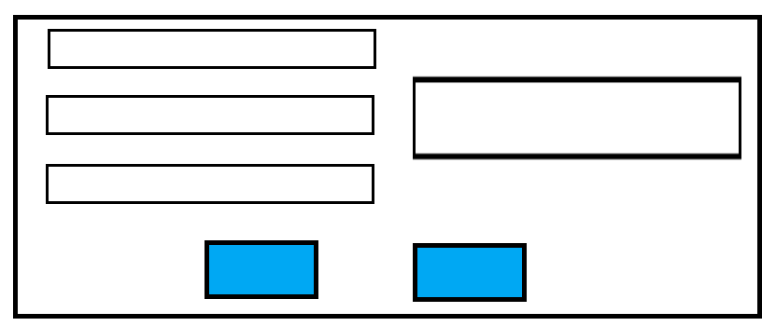

Let’s say the there are 4 labels and 2 (blue) buttons. The user could press either the left or the right button, and in different number of times. So the event handler of each button can not make assumptions of what’s on the GUI screen. We will come back to this question after we learn about some more widgets.

Designing a GUI – placing widgets

In general, place widgets on an interface so that when the program is executing, and the user is interacting with the program, they are interacting with components following a general top-down/left-right flow order.

The components can be created in the code in any order, but once a program starts, the user should be reading/entering/moving the mouse starting from the upper left part of the window and moving to the bottom right. This guideline cannot always be strictly enforced, of course, but the general flow should go upper left, moving to the lower right.

Exercises 04.02 Event programming

As always, just use techniques learned in class.

04.02.01
Write a program that has 2 labels, both with no initial text. Then add two buttons, so that clicking on one button changes the text in the first label to a favourite food, and pressing the other button changes the text in the second to a favourite sports team.

04.02.02
Write a program that has 1 label, and 1 button. The label initially has the message “I’m happy!”. When the button is clicked, the message will change to “I’m sad!”. Clicking again, the message will revert to “I’m happy!”, and so on, alternating between the messages.

04.02.03
Create a GUI that has one label showing any phrase you wish. Add two buttons, one to change the foreground colour, and one to change the background colour. You decide what colours to use when you write the program.

04.02.04
Create a GUI that has two labels showing any phrases that you wish. Add two buttons. One button changes the background colour of one label. The other button changes the background colour of the other label.

04.02.05
Write a program that has four labels and one button. Clicking on the button will make the first label’s background colour to “red”. Clicking on the button a second time will make the second label change colour to “white”, etc. In sequence, the colour of the next button will change from “red” to “white” to “green”, then back again.
Hint: This requires a bit of decision making and programming new math…

